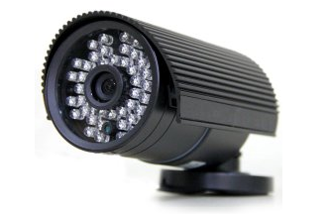**Birdhouse (OB-CM600IR100-B)**

Purchased: Sept, 2013

Resolution: 600 TBL

Camera: 1/3” CMOS

Focal Length: 3.6mm

Cost: $70.25

Weatherproof

48 LEDs with IR CUT

Vendor: Security Camera King

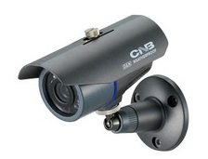**Basement Door**

Purchased: May, 2014

Resolution: 600 TVL

Camera: 1/3” CCD

Focal Length: 3.8mm

Cost: $81.00

Weather Proof

Vendor: CNB

**Garage Door:** 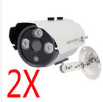

Purchased: Sept. 2014

Resolution: 700 TVL

Camera: 1/3” CCD

Focal Length: 6mm

Cost: $60.50 (bought 2, only 1 worked; Returned, but no replacement)

Weather Proof

3 LED with IR CUT

Vendor: (eBay) eztrade2world

**Garage Door (after addition)** 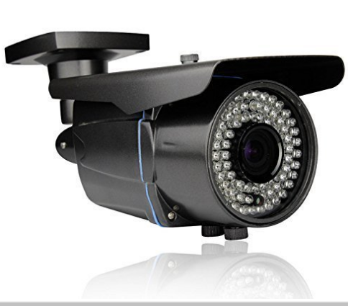

Purchased: June 2016

Resolution: 1000 TVL

Camera: 1/3” CMOS

Focal Length: 2.8 – 12mm

Cost: $61.50

Weather Proof

72 LED with IR Cut

Vendor: (Amazon) Starview Security Inc.

**Unused**

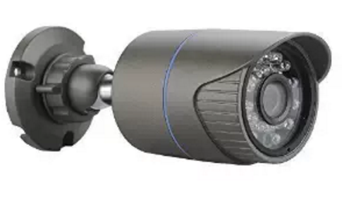Purchased: June, 2016

Resolution: 1000 TBL

Camera: 1/3” CMOS

Focal Length: Says 3.6mm, but more like 5mm

Cost: $19.50

Weather Proof (IP66)

30 LEDs with IR Cut

Vendor: (Amazon) SmoTecQ